**FOOD2EAT**

**A PROJECT REPORT**

**Submitted by**

**NAME OF THE CANDIDATE(S**)

*in partial fulfillment for the award of the degree*

*of*

**NAME OF THE DEGREE**

*in*

**BRANCH OF STUDY**

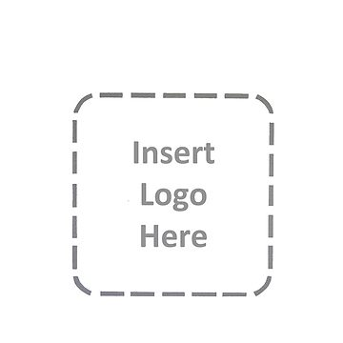

**NAME OF YOUR INSTITUTE**

**NAME OF UNIVERSITY**

**MONTH & YEAR**

i

**CERTIFICATE**

**Certified that this project report “……….TITLE OF THE PROJECT……………..” is the bonafide work of “…………..NAME OF THE CANDIDATE(S).…………” who carried out the project work under my supervision.**

|  |  |  |
| --- | --- | --- |
| **<< Name>>**  **Guide** | **<< Name>>**  **Head of the Department** | **<< Name>>**  **Principal** |

**NAME OF YOUR DEPARTMENT**

**NAME OF YOUR INSTITUTE**

**NAME OF UNIVERSITY**

ii

**ACKNOWLEDGEMENT**

I would like to express my special thanks of gratitude to my project guide << Name of guide>> as well as our principal << Name of guide>> who gave me the golden opportunity to do this wonderful project on the topic food2eat, which also helped me in doing a lot of research and i came to know about so many new things I am really thankful to them.

Secondly I would also like to thank my parents and friends who helped me a lot in finalizing this project within the limited time frame.

|  |  |
| --- | --- |
| Date : | << Your Name >> |
| Place : | << Roll no >> |
|  | << Class >> |

iii

**Development Tools:**

* **HTML, CSS**
* **Google Analytics**
* **Google Tag Manager.**
* **Google Spreadsheet**
* SEM

## **Web application hardware requirements:**

The following table lists the minimum and recommended hardware requirements for the web application.

|  |  |  |
| --- | --- | --- |
| **Component** | **Minimum** | **Recommended** |
| Processor | 1.9 gigahertz (GHz) x86- or x64-bit dual core processor with SSE2 instruction set | 3.3 gigahertz (GHz) or faster 64-bit dual core processor with SSE2 instruction set |
| Memory | 2-GB RAM | 4-GB RAM or more |
| Display | Super VGA with a resolution of 1024 x 768 | Super VGA with a resolution of 1024 x 768 |

**Web Server:**

* Apache(local host)
* Hostinger(server host)

**Web Browser:**

* Google chrome (or any other browser supported HTML)

**Website look**

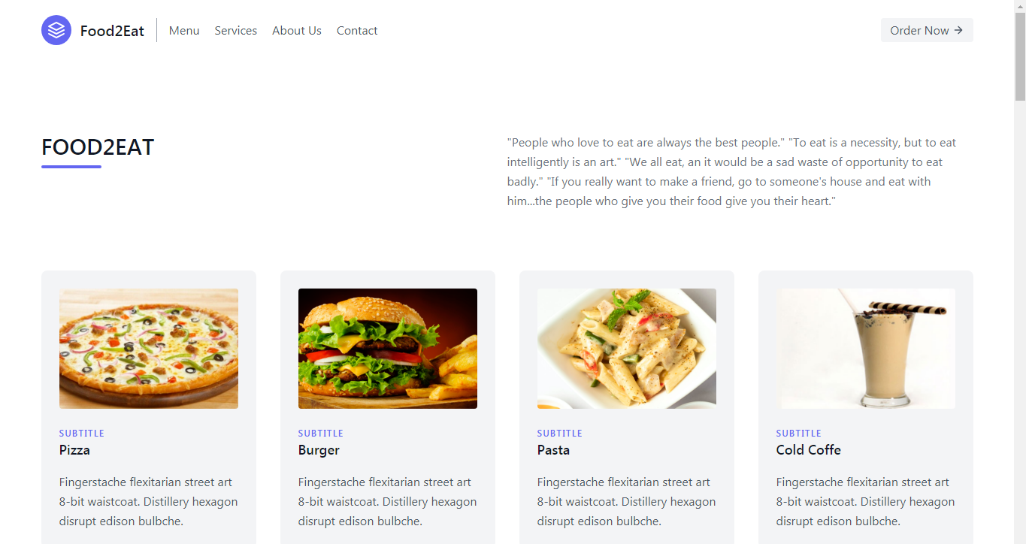

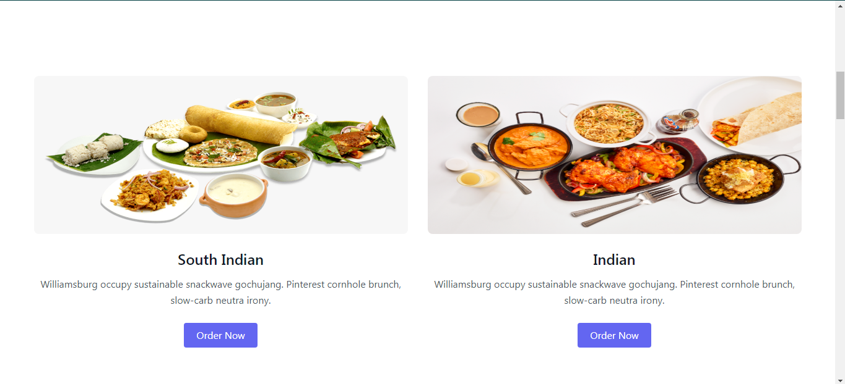

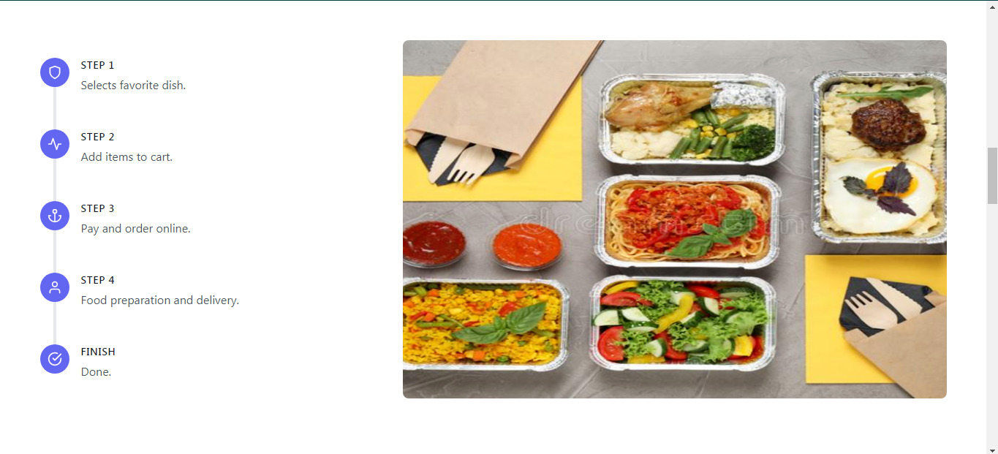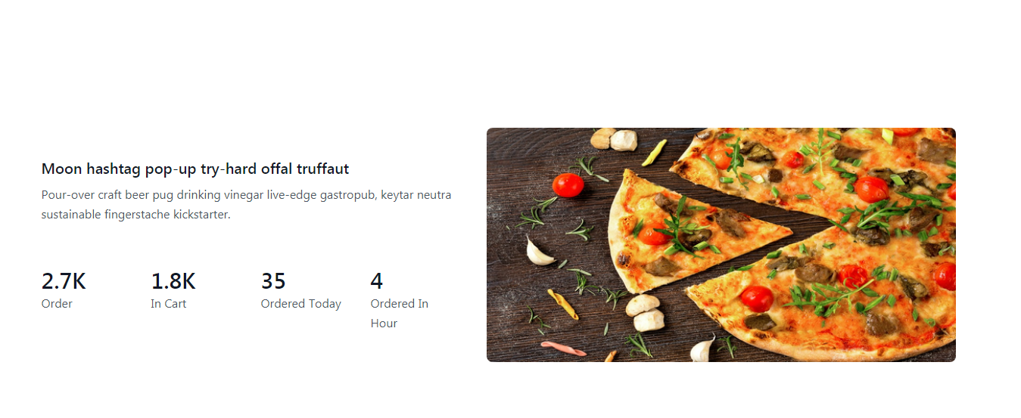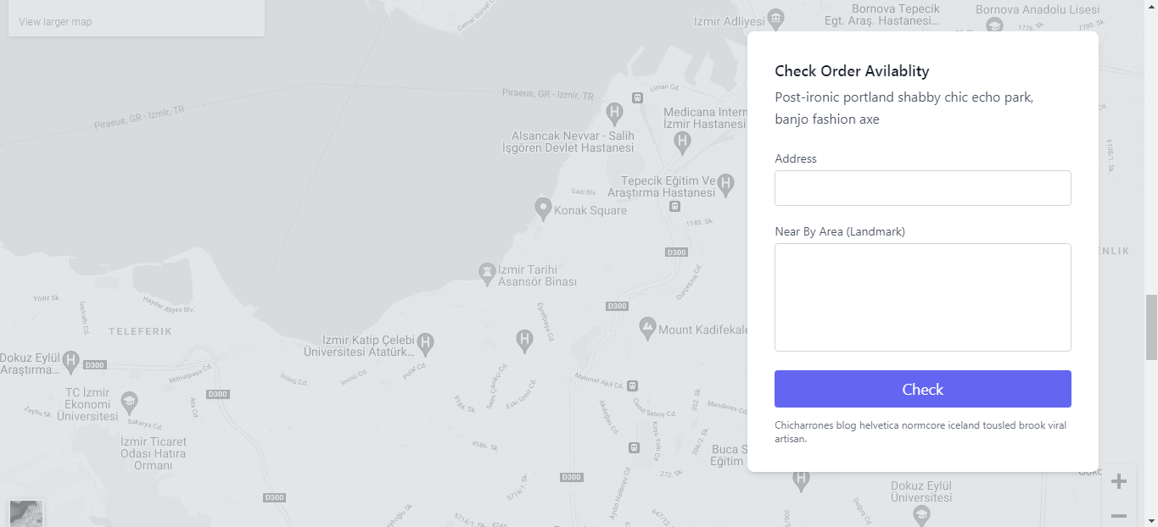

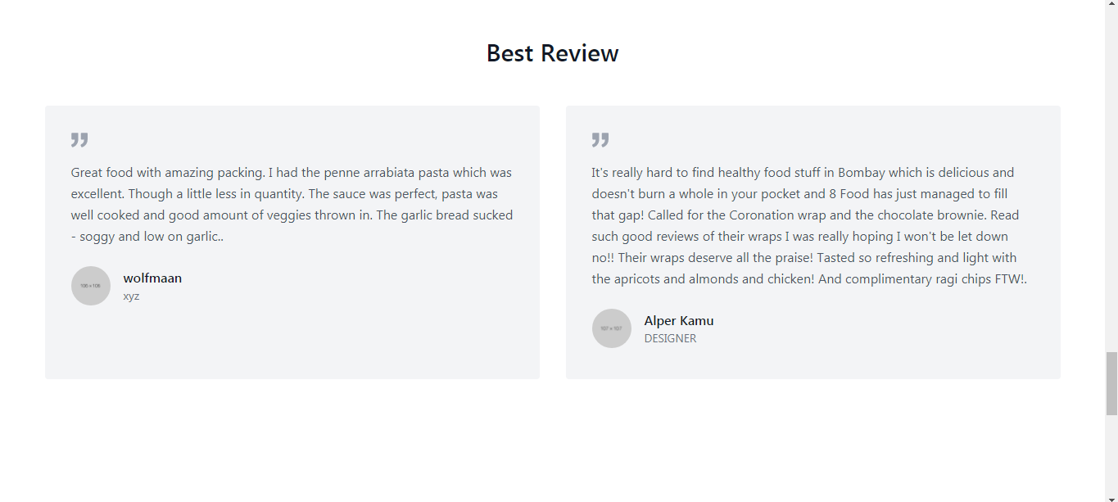

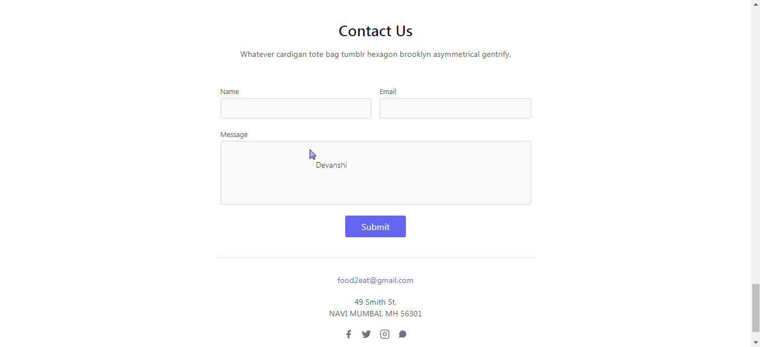

**Objectives:**

**Website Requirements:**

* Design Wireframes, functional flowcharts before programming.
* Later, Design Mock-ups of the design in responsive sizes for demonstration.
* Has to be at least 7 pages
* Make sure the site is fast and mobile-friendly using Bootstrap or any other frameworks
* (Tests required)
* Make sure there is proper interlinking on the site.
* Make sure there is a call to action on each page of the site.
* Design carousels, backgrounds, web assets on Adobe Photoshop and incorporate them into the website.

**Milestone - 1**

- Install Google Analytics on the site. Provide a proof that the tag implemented is functioning

properly.

- Customize Google Analytics to track goals.

* Create a time related Goal.
* Create a page /visit related goal.
* Create a destination related goal.

- Identify all the micro and macro conversions on the site.

- Setup the proper permissions in Google Analytics.

- Install Google Tag Manager.

* Create the necessary Tags and Triggers to make sure GTM is working properly.
* Test to make sure your site analytics & GTM is functional.

- Create a customized dashboard to measure all the data and showcase it.

- Create a keyword map for the site.

* Provide 2 keywords per page
* Provide 2 Questions per page
* Make sure that the keywords are unique
* Make sure that the keywords are not too competitive
* Make sure that the keywords have traffic associated with them

**Milestone - 2**

- Create SEO Content Recommendations:

* Create a Meta Title tag for each page on the site.
* Create a Meta Descriptions tag for each page on the site.
* Make sure there is a logical structure for the site.
* Create H1, H2, H3 for each page.
* Implement all the tags to the site.
* You are required to include images on each page of the site and to make sure they are
* tagged properly.
* You are expected to have a shareable website.
* You are expected to install popups.
* Create an FAQ on the site (Base it on market questions)

**Milestone - 3**

- Create social media channels on (FaceBook, Twitter, LinkedIn, Pinterest, Instagram, and

Youtube). Make sure they are populated properly.

- Create a social media calendar for FaceBook, Twitter, LinkedIn, Pinterest, Instagram, and

Youtube.

**Milestone - 4**

- Create an SEM Campaign Structure for the site.

* Create ADS and Keywords for at least 6 ad groups.
* Create 3 different campaigns
* Create a competitive, Branded and Generic Campaign
* Make sure that you are tapping into the local aspect.
* Make sure that there is a logical campaign structure
* Make sure to use at least 2 types of ad extensions.

**Work:**

Milestone 2

1- Create a Meta Title tag for each page on the site.

A title tag is an HTML element that specifies the title of a web page. Title tags are displayed on search engine results pages (SERPs) as the clickable headline for a given result, and are important for usability, SEO, and social sharing. The title tag of a web page is meant to be an accurate and concise description of a page's content.

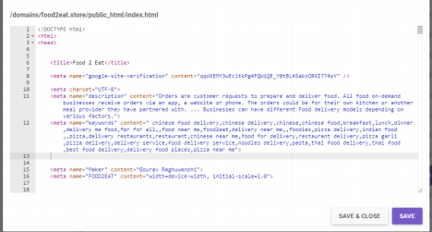

2-Create a Meta Descriptions tag for each page on the site.

The meta description is an HTML attribute that provides a brief summary of a web page. Search engines such as Google often display the meta description in search results, which can influence click-through rates.

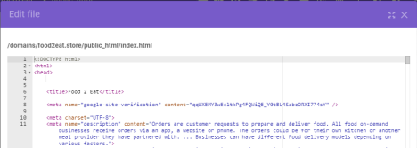

3-Make sure there is a logical structure forthe site.

A logical structure is one where the document is divided into a number of sections. Each has their own headers, paragraphs, lists and images so that information flows logically from one section to the next. Get rid of all those tables, JavaScript menus, maps and layers.

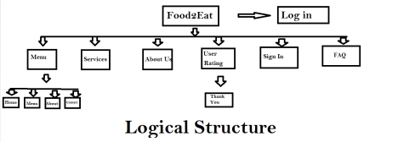

4-Create H1, H2, H3 for each page.

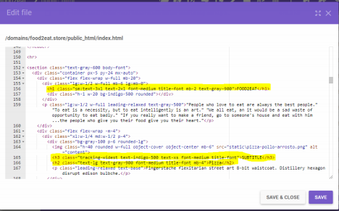

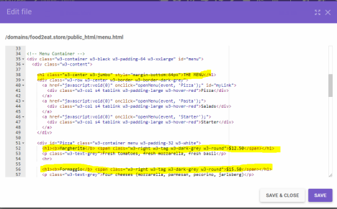

5-You are required to include images on each page of the site and to make sure they are tagged properly.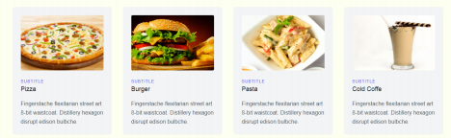

6-You are expected to have a shareable website.

It has a domain http://food2eat.store and hosting also so, it's a shareable website.

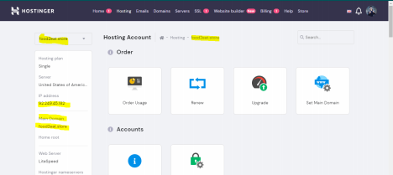

7-Create an FAQ on the site (Base it on market questions)

*A frequently asked questions (FAQ) forum is often used in articles, websites, email lists, and online forums where common questions tend to recur, for example through posts or queries by new users related to common knowledge gaps.* The purpose of an FAQ is generally to

provide information on frequent questions or concerns; however, the format is a useful means of organizing information, and text consisting of questions and their answers may thus be called an FAQ regardless of whether the questions are actually *frequently* asked.

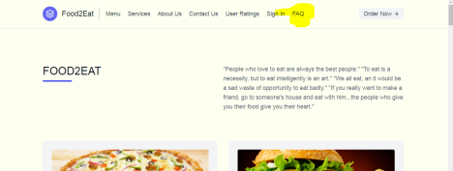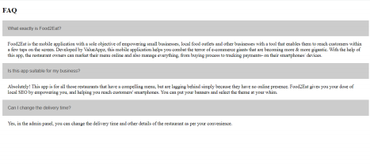

**Milestone-3**

**FOOD2EAT**

**1-Create social media channels on :**

**FaceBook-** [**https://www.facebook.com/Food2Eat-102133795441181**](https://www.facebook.com/Food2Eat-102133795441181)

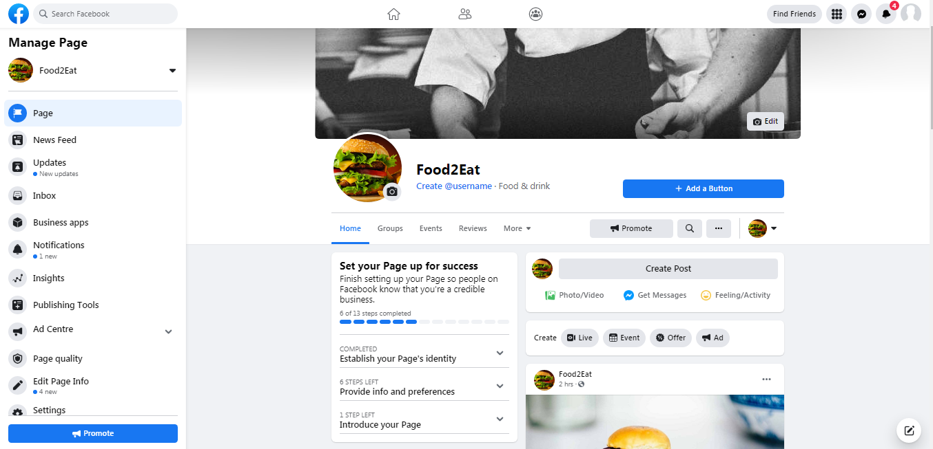

**LinkedIn-** [**https://www.linkedin.com/in/food-eat-71b080214/**](https://www.linkedin.com/in/food-eat-71b080214/)

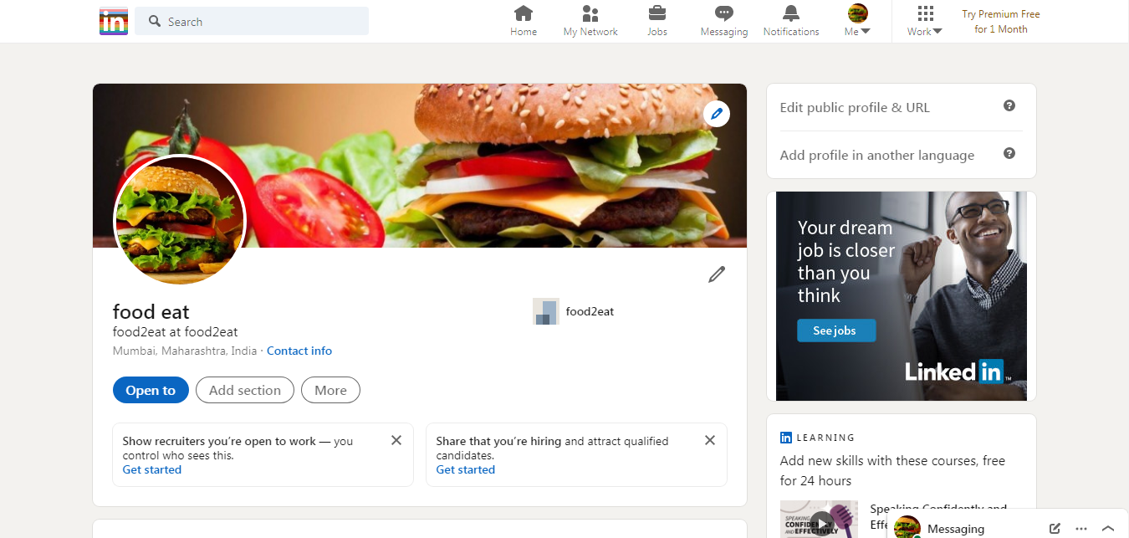

**Pinterest-** [**https://in.pinterest.com/01wq0xjol1qoyg4p6ghxer66lafvg7/_saved/**](https://in.pinterest.com/01wq0xjol1qoyg4p6ghxer66lafvg7/_saved/)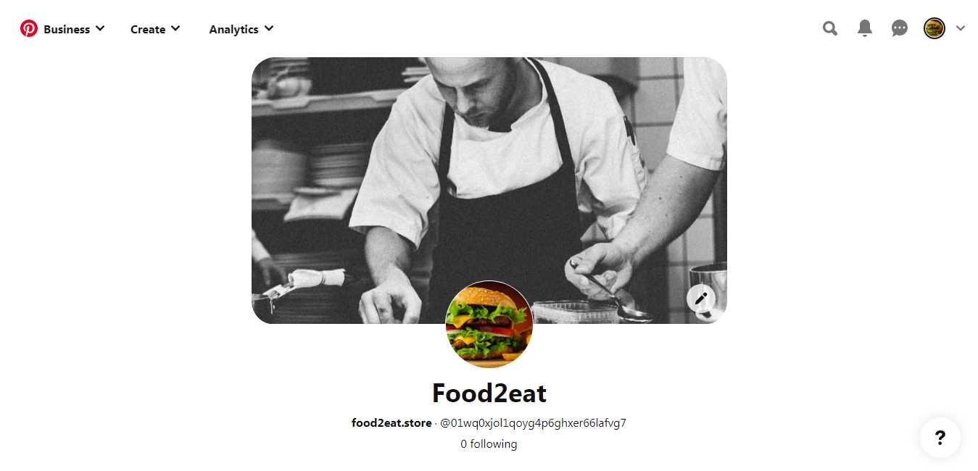

**Instagram-** [**https://www.instagram.com/food___2___eat_2020/**](https://www.instagram.com/food___2___eat_2020/)

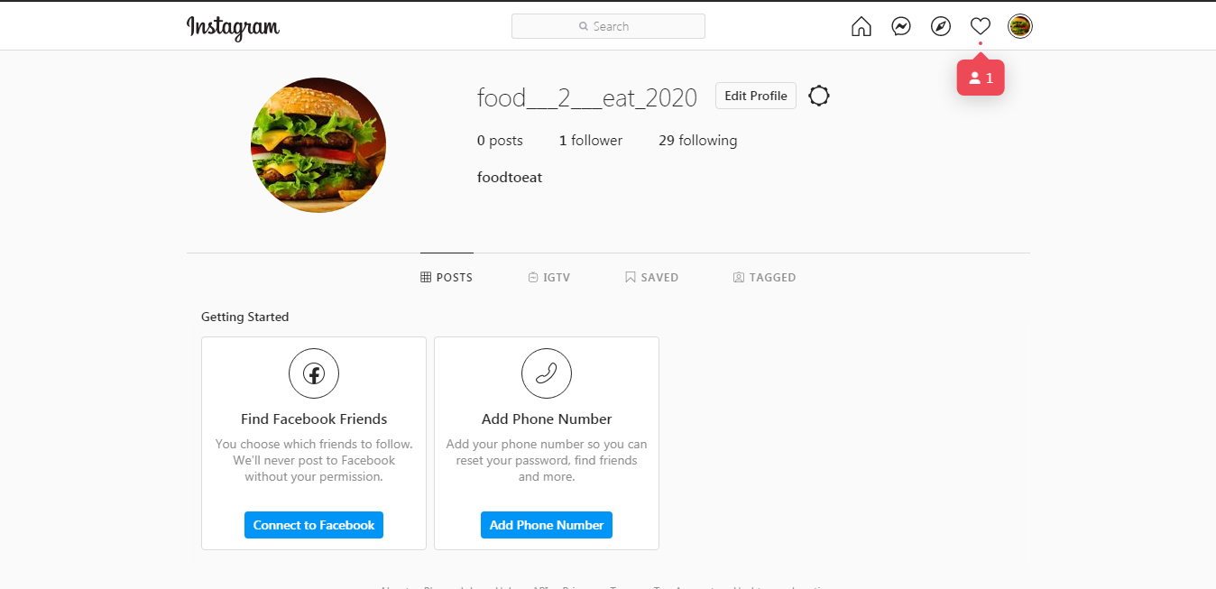

**Youtube-** [**https://www.youtube.com/channel/UCitXO7re5AGtp6MaOe6p3Hw**](https://www.youtube.com/channel/UCitXO7re5AGtp6MaOe6p3Hw)

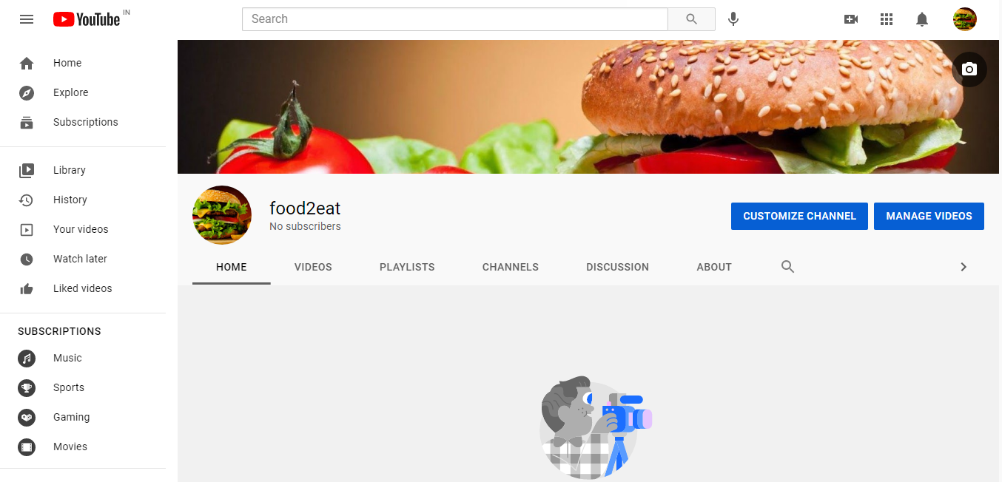

**Create a social media calendar for FaceBook, Twitter, LinkedIn, Pinterest, Instagram, and**

**Youtube.You are expected to send:-**

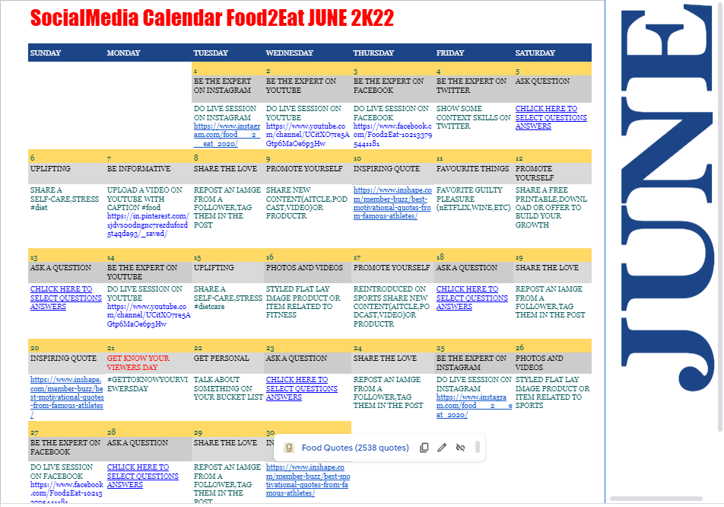

**MILESTONE-4**

**Food2Eat**

**Create an SEM Campaign Structure for the site.**

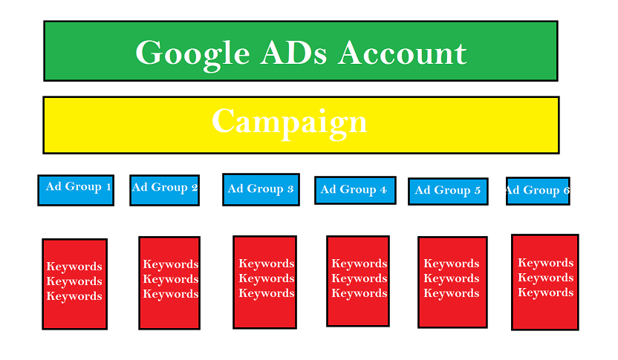

**o Create ADS and Keywords for at least 6 ad groups.**

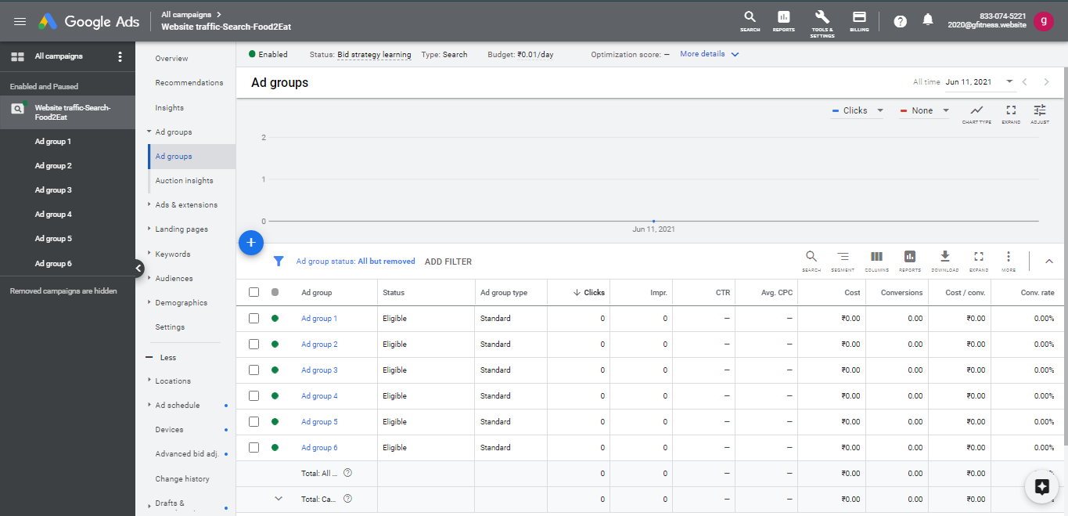

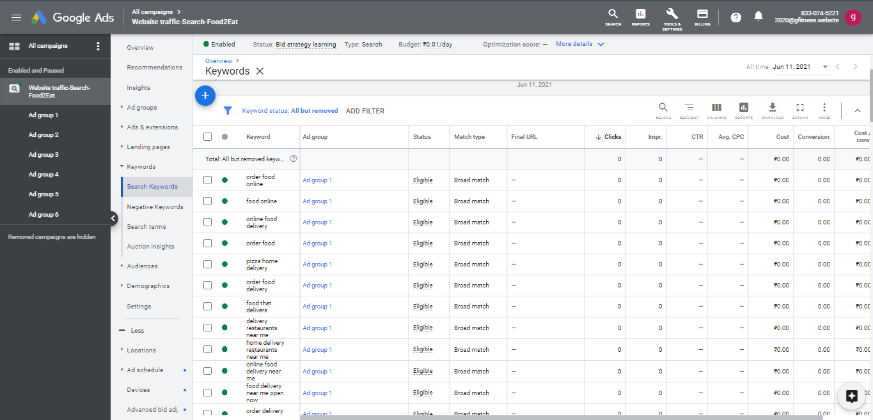

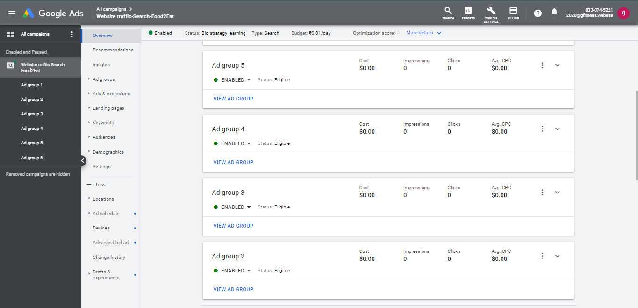

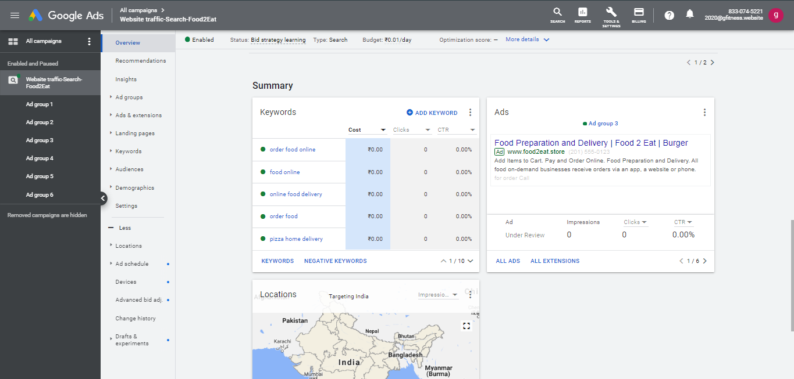

**o Create campaign for ad on your site**

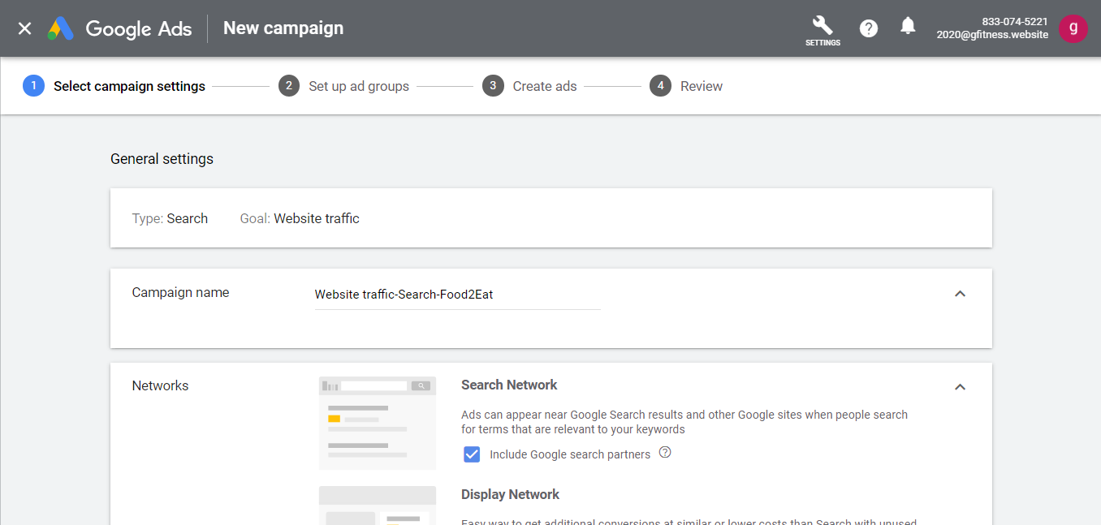

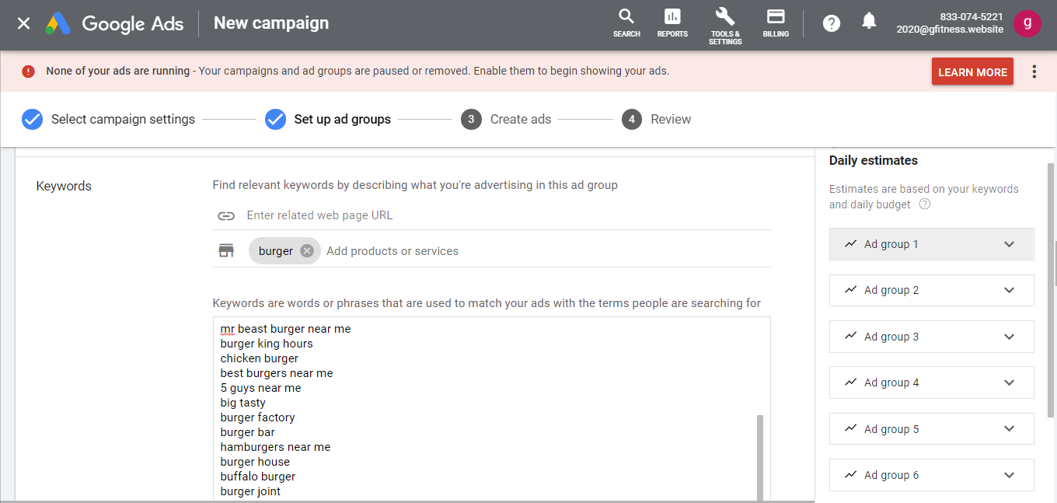

**o Make sure that you are tapping into the local aspect.**



**o Make sure that there is a logical campaign structure**

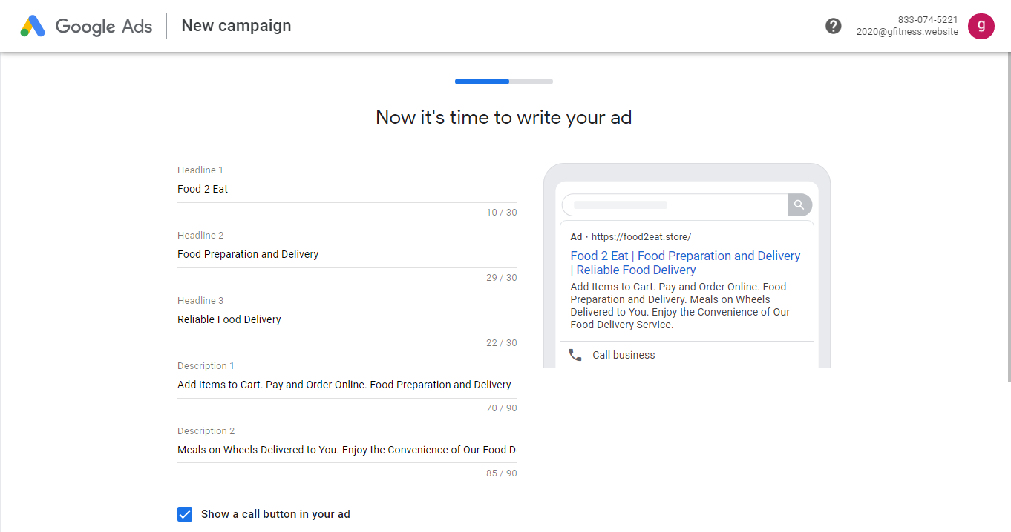

**o Make sure to use at least 2 types of ad extensions.**

